 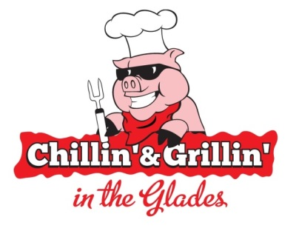 

**Chillin & Grillin in the Glades – July 19th & 20th, 2019**

**2019 Heavenly Dessert Contest Entry Form**

Is your dessert the talk of the town? People can’t get enough of your cake? The pudding or pie that you make is to die for? Then you need to enter the Inn at Wise 2018 Heavenly Dessert contest! Yes, that’s right, this year there are no restrictions. You prepare whatever you best dessert recipe is. The winner is guaranteed a cash prize of $200 + a free overnight stay at the Inn at Wise! All you have to do is fill out this form, pay the entry fee, and start baking!

Name: _____________________________________________________________

Team Name (If Applicable): _____________________________________________

Mailing Address: ______________________________________________

City: __________________________ State & Zip: ____________________

Day Phone: ___________________ Cell Phone: ______________________

Email Address: ________________________________________________

ENTRY FEE $10

Check enclosed____

Rules:

* All entry forms must be received by July 19, 2019.
* All dessert entries must be delivered to the Ball Room of the Inn at Wise between 2:15pm and 2:30pm, Saturday, July 20, 2019.
* **NO DESSERT ENTRIES WILL BE ACCEPTED BEFORE OR AFTER THIS TIME!**
* Desserts will be judged based on their appearance, texture and taste.
* There must be enough of your dessert turned in to provide at least 6 samples.
* The winner will be announced in The Big Glades, Saturday, July 20th at 4:30pm.

***Committee reserves the right to reject any application. If your application is not accepted, your money will be refunded; however, there will no refunds given after a person or team is accepted into the competition. This is a rain or shine event.

**Waiver of Liability:**

For valuable consideration and in consideration of the Event Sponsors accepting this entry, I, the undersigned, intending to be legally bound, hereby, for myself (or for my organizational entity), my heirs, personal representatives, my team members, executors and administrators, their representatives, successors, employees, and with the consent and authority of my team members and guests, do hereby release, indemnify and hold harmless the Chillin and Grillin in the Glades Event Committee (the “Event”), the Town of Wise, the Wise Business Association, the Inn at Wise, their representatives, successors, employees (the “Event Sponsors”), and all event volunteers for any and all claims arising from or during the Event against the above named parties, including without limitation, all costs liabilities, judgments, expenses, damages or reasonable attorney fees, including but not limited to claims arising from or in connection with the following: (I) any structure erected by the contestant, (II) any apparatus, equipment or personal property used by contestant, (III) an act or omission to act of agents, and (IV) any claims made on account or resulting from contestant’s participation in the contest. My signature below and enclosed payment indicates that the above named individuals agree to abide by the rules and regulations of the Event. Failure to do so may result in the termination of my application and my participation in future events of the Event Sponsors. Further, I grant full permission to the Event Committee and the Event Sponsors, to use any and all photographs, images, videotapes, recording or any other record of the event for any lawful purpose.

________________________________________________ ____________________

Signature Date

**Mail Entry Form To: Or *E-Mail Entry Form To:**

Chillin’ and Grillin’ Heavenly Dessert Contest nicolek@inatwise.com

Attn: Nicole King

P.O. Box 4029

*Wise, VA. 24293*

* Entry Fee must be received before your entry will be accepted.

For additional information, contact Nicole King, 276-321-7600 or email nicolek@innatwise.com

